1.Abstract:
The creation of an Automatic Bag Valve Mask (BVM) ventilator is crucial in medical emergencies and resource-limited settings, a reality underscored during situations like the COVID-19 pandemic when traditional ventilators were in short supply. This initiative aims to design and simulate a pressure-controlled Automatic BVM Ventilator using MATLAB Simulink, facilitating virtual prototyping of a dependable and affordable ventilator system. By incorporating pneumatic airflow management, valve activation, lung modelling, sensors, and closed-loop pressure control, the simulation effectively mirrors actual breathing patterns for adults, children, and individuals with COPD. This simulated system, like other low-cost ventilator systems that use medical-grade gases and flow interruption tactics to reduce mechanical complexity, illustrates that necessary ventilatory assistance may be given safely and efficiently with fewer components. The findings confirm that MATLAB Simulink is an effective platform for pre-implementation testing, which reduces development costs, improves safety, and ensures that the ventilator design meets important performance requirements for emergency usage in clinical settings.
2.Table of Contents:
- Abstract
- Table of Contents
- Introduction
- Literature Review
- Methodology
- Main Body / Discussion
  - Detailed Explanation of the Topic
  - Technical Details
  - Applications / Case Studies4
  - Analysis
- Model workflow
- Result
- Reference
- Appendices

3.Introduction:
The increasing demand for ventilatory support, especially highlighted during the COVID-19 pandemic, has exposed severe shortages of advanced mechanical ventilators and skilled personnel, even in well-resourced healthcare systems. COVID-19 frequently leads to respiratory distress, hypoxemia, and respiratory failure, causing a significant proportion of patients to require ICU admission and mechanical ventilation. Traditional ventilators, though highly sophisticated, expensive, and maintenance-intensive, are often unavailable during emergencies, leaving critical gaps in patient care. To address these limitations, this project focuses on developing a low-cost, pressure-controlled ventilator (PCV) model that can assist or fully support a patient’s breathing by regulating peak airway pressure, making it suitable for sensitive or compromised lungs. The proposed system incorporates key subsystems such as a pneumatic pressure source, inspiratory and expiratory valves, a lung model, sensors, and a closed-loop pressure controller. Designed and tested using MATLAB Simulink and Simulink, the model ensures accurate representation of real ventilator dynamics and demonstrates how simplified, easy-to-deploy ventilator solutions—similar to emergency-use low-cost designs—can provide reliable respiratory support in crisis situations and resource-limited environments.
4.Literature Review:
- Mechanical Ventilators in Emergency Care: Research shows that pressure-controlled ventilation reduces the risk of Ventilator-Induced Lung Injury (VILI) by limiting peak airway pressure.
- BVM-Based Automated Ventilators: Many low-cost emergency ventilators use a mechanical actuator to compress an AMBU bag. However, they lack adaptive pressure control and monitoring.
- MATLAB Simulink for Biomedical Simulation: Simulink provides component-level modelling of pneumatic systems, enabling accurate simulation of respiratory dynamics.
- Ventilator Design Challenges:
Key challenges include:
• maintaining stable airway pressure,
• synchronizing inspiratory/expiratory phases,
• modelling patient lung compliance and resistance,
• ensuring safety mechanisms like PEEP and pressure limits.
5.Methodology:
The project follows a simulation-based design approach:
- Problem Identification
Lack of affordable ventilators in emergencies demands a low-cost, controllable, reliable ventilator system.
- Subsystem Identification
  - Pneumatic system
  - Inspiratory valve control
  - Expiratory valve + PEEP
  - Pressure controller
  - Lung model (compliance, resistance)
  - Sensors (pressure, flow)
- Model Development in Simulink/Simulink
  - Integration of gas sources and flow valves
  - Creation of PCV logic
  - Implementation of breathing cycles
- Simulation of Patient Types
  - Normal adults
  - Children
  - COPD patients
- Performance Evaluation
Parameters studied:
  - Pressure waveform stability
  - Volume delivery
  - Airflow behaviour
  - Response to lung condition variations
6. Main body/Discussion:
  - Detailed Explanation of the Ventilator System
- Pneumatic System:
A controlled pressure source provides compressed air to the breathing circuit. Simulink’s Controlled Pressure Source block is used.
- Inspiratory Valve
Modelled as a solenoid-like valve using a flow-control orifice. It regulates inspiratory airflow.
- Expiratory Valve + PEEP System
A controlled flow valve manages exhalation, while PEEP maintains positive pressure to prevent lung collapse.
- Pressure Controller
Generates pressure reference waveform and controls valve actuation during inspiration phase and expiration phase
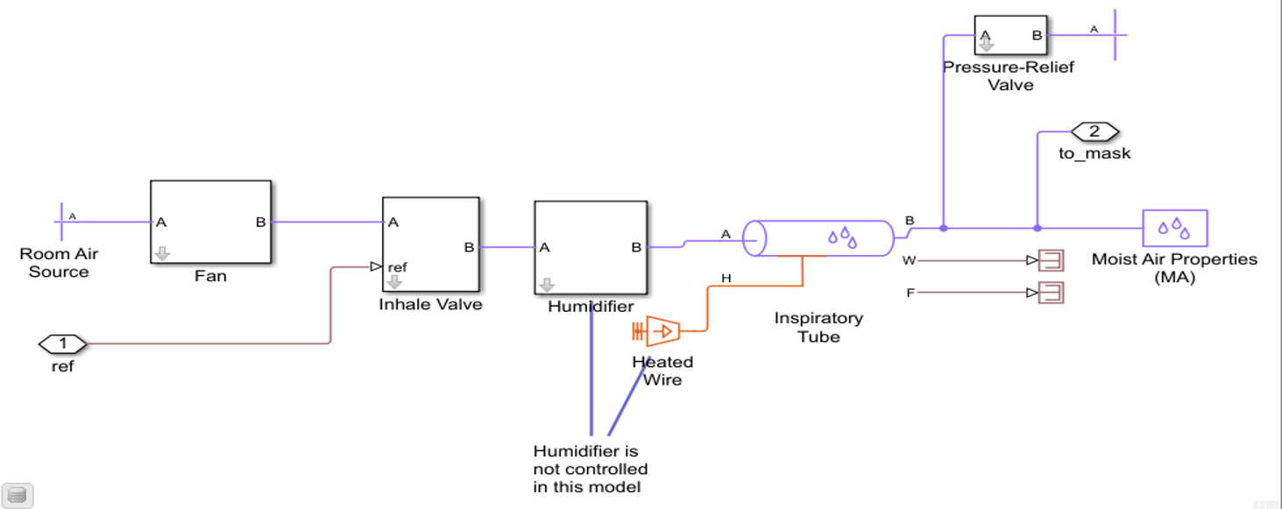The controller ensures stable pressure-controlled ventilation.
- Patient Lung Model (AMBU bag + Lung Mechanics)
Simulink lung model includes:
Compliance (C) — elasticity of lung tissue
Resistance (R) — airflow resistance
Dead space volume
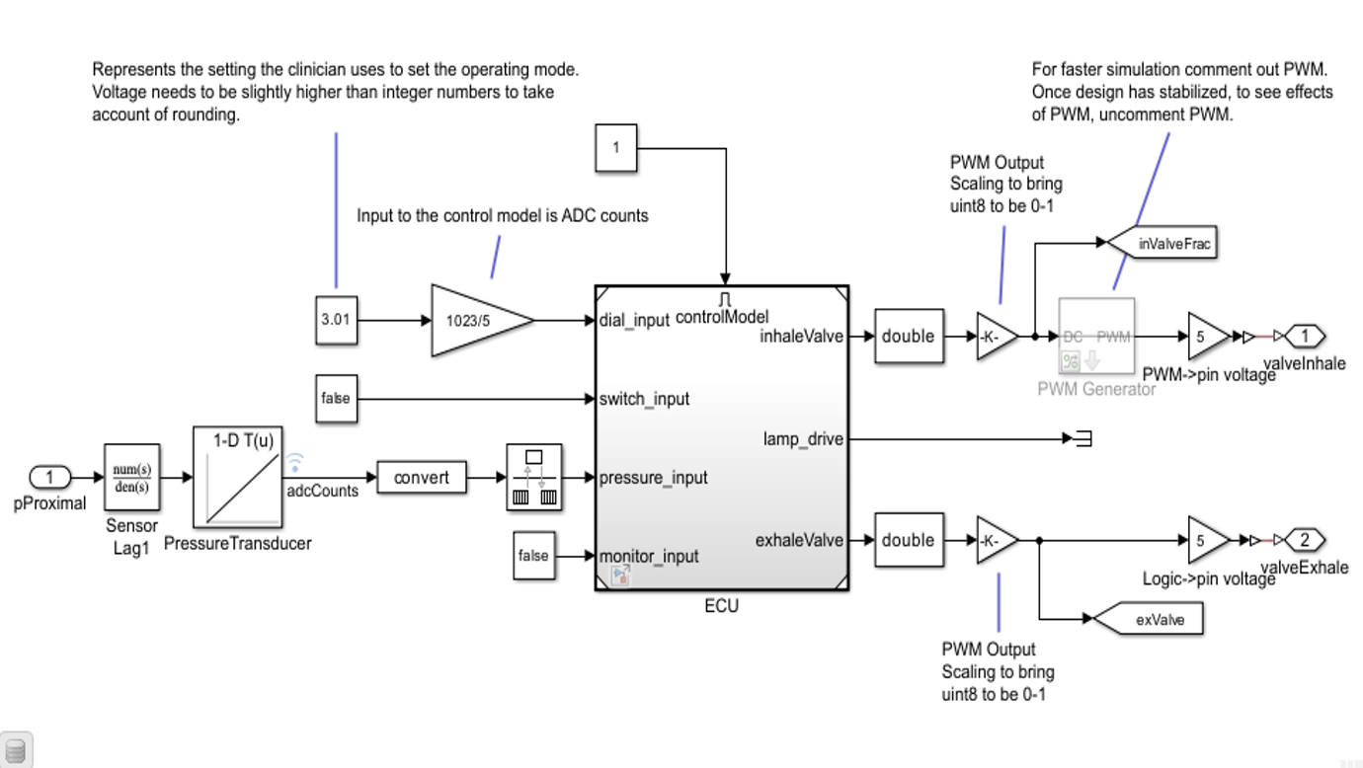
6.2 Technical Details
Key Parameters and Equations
- Pressure-Controlled Ventilation Equation
$$P(t)=P_{peak}⋅u(t)+PEEP$$
where u(t) is valve-controlled inspiratory timing.
- Lung Volume Equation
$$V=C⋅(P-PEEP)$$
- Flow Equation
$$Q=\frac{P_{insp}-P_{lung}}{R}$$
Simulink Components Used
- Controlled Pressure Source
- Flow Control Valve
- Gas Resistances & Compliances
- Scope & Sensor blocks
- Block-Level Architecture
- Pneumatic supply
- Inspiratory valve
- Expiratory valve
- Controller
- Lung model
- Sensor feedback
6.3 Case Studies / Applications
The model was tested for:
- Adults & Elderly (20–60 yrs)
Normal compliance and resistance.
- Children
Lower tidal volume & higher respiratory rate.
- COPD Patients
Increased airway resistance and decreased elasticity.
Results show delayed exhalation and altered pressure waveform.
6.4 Analysis
- Pressure Stability:
The PCV controller maintained stable target pressures across patient types.
- Valve Dynamics:
Inspiratory and expiratory valve responses were accurately synchronized.
- Lung Behaviour:
Lung compliance greatly affected delivered tidal volume, highlighting the need for adaptive control.
- COPD Simulation:
Demonstrated increased pressure retention and slower airflow decay.
- System Performance:
The simulated ventilator successfully replicated full breathing cycles with PEEP protection.
7.Model workflow
- Start: Ventilator system initializes.
- Maintain PEEP & Monitor: Keeps minimum airway pressure and checks sensors.
- Breath Trigger: Detects if patient or timer initiates a breath.
- Begin Inspiration: Starts inhalation process.
- Set PIP: Sets target peak inspiratory pressure.
- Open Inspiratory Valve: Allows air to enter the lungs.
- Check Target Pressure: Compares airway pressure with PIP.
- Adjust Inspiratory Valve: Modifies valve opening if pressure not reached.
- Inspiration Hold End: Maintains inhalation until set time ends.
- Start Expiration: Switches to exhalation phase.
- Open Expiratory Valve: Opens valve for passive exhalation.
- Passive Exhalation with PEEP: Patient exhales while maintaining PEEP.
- Expiration Complete: Detects when exhalation ends.
- Log Data: Records pressure, flow, and volume values.
- Safety Check: Verifies if any safety limit is crossed.
- Trigger Alarm & Override: Activates alarms and safety actions if needed.
8.Results:
The obtained outputs from simulations included pressure, flow, and volume waveforms for:
  - Adults/Aged Patients: Stable pressure waveform and normal breathing cycle.

  - Children: Lower lung volume but stable pressure-controlled operation.
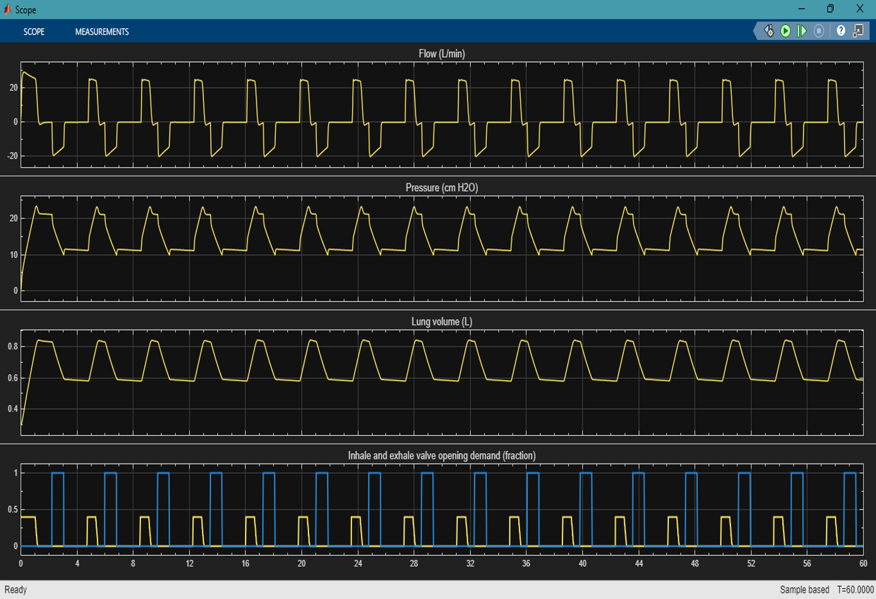
  - COPD Patients: Increased resistance observed with characteristic delayed exhalation waveform.

9. Conclusion:
This project demonstrates that MATLAB Simulink provide a robust environment for designing and validating a pressure-controlled ventilator system before physical prototyping. The automatic BVM ventilator model accurately simulated pneumatic subsystems, valve control, lung mechanics, and safety logic. The system performed effectively for different patient conditions, proving its value in emergency and low-resource medical environments. Overall, the project establishes a foundation for developing a real, low-cost intelligent ventilator system.

10. Reference
- Clark M. Jit, Warren-Gash C., Guthrie B., Wang H. H. X., Mercer S. W., et al. "Global, regional, and national estimates of the population at increased risk of severe COVID-19 due to underlying health conditions in 2020: a modelling study," The Lancet Global Health, pp. 1003–1090, 2020
- Odone D. Delmonte, Scognamiglio T.and a. Signorelli C., "COVID-19 deaths in Lombardy, Italy: data in context," The Lancet Public Health, vol. 5, pp. 2468–2667, 2020. https://doi.org/10.1016/S2468-2667 (20)30099-2 PMID: 32339478
- Wadhera R. K., Wadhera P., Gaba P., Figueroa J. F., Maddox K. E. J., Yeh R. W., et al. "Variation in COVID-19 Hospitalizations and Deaths Across New York City Boroughs," JAMA, vol. 21, pp. 2192– 2195, 2020. https://doi.org/10.1001/jama.2020.7197 PMID: 32347898
- WHO Guidelines on Emergency Ventilation
- MATLAB & Simulink Documentation
11.Appendices:
Appendix A – Simulink Model Screenshots
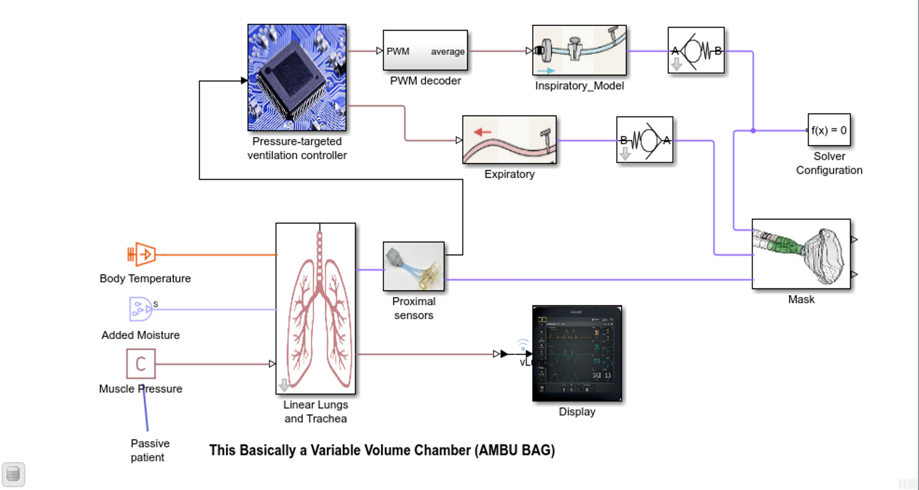

Appendix B – Parameter Tables
- Lung compliance
- Resistance
- PEEP settings
- Pressure waveform characteristics

Appendix C – Additional Graphs
- Pressure vs Time
- Flow vs Time
- Volume vs Time

